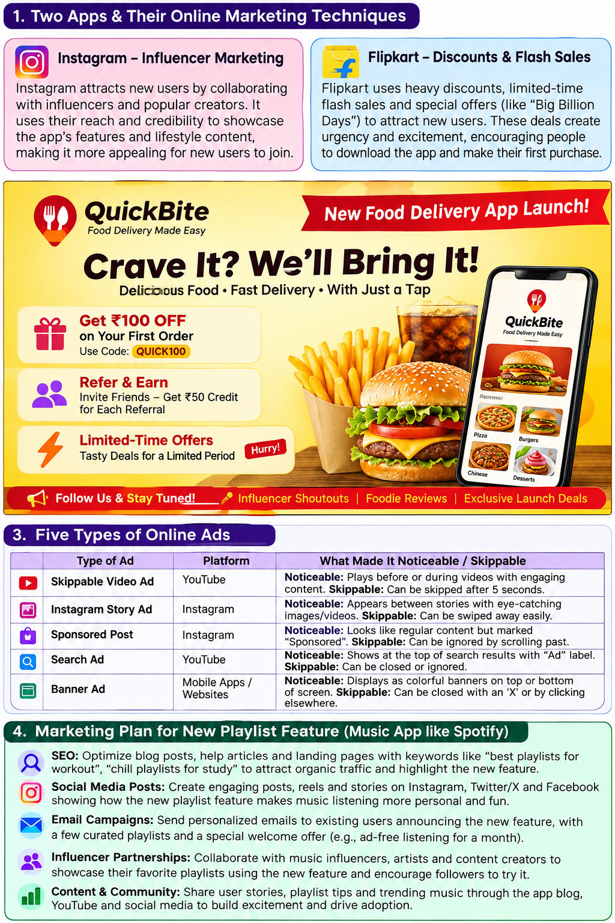
1. Two Apps & Their Online Marketing Techniques
Instagram – Influencer Marketing:
Instagram attracts new users by collaborating with influencers and popular creators. Influencers showcase the app and its features to their followers, increasing awareness and downloads.
Flipkart – Discounts & Flash Sales:
Flipkart uses discounts, limited-time offers, and major sales to attract new users. Deals create urgency and encourage people to download the app and make their first purchase.
2. Digital Flyer – New Food Delivery App
I created a QuickBite launch flyer featuring:
- ₹100 OFF on the first order with referral/promo code QUICK100
- Refer & Earn rewards
- Limited-time offers
- Influencer shoutouts and food reviews
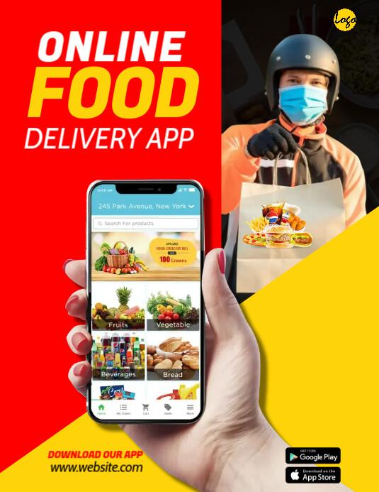
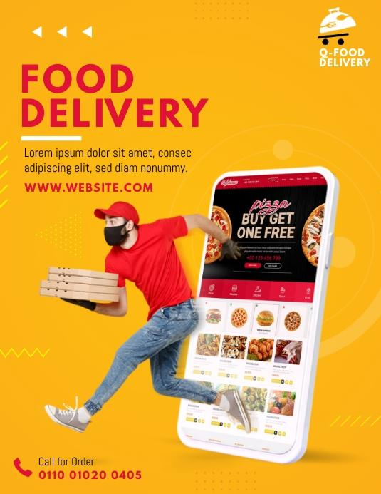
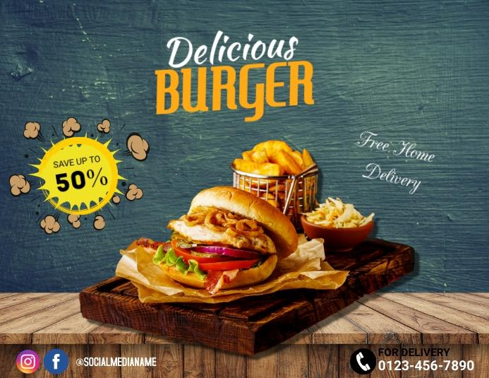
6
3. Five Types of Online Ads
Ad Type | Platform | Noticeable / Skippable
Skippable Video Ad | YouTube | Eye-catching videos are noticeable; can usually be skipped after a few seconds.
Instagram Story Ad | Instagram | Attractive images/videos grab attention; users can swipe away.
Sponsored Post | Instagram | Looks like regular content but is marked “Sponsored”; can be ignored by scrolling.
Search Ad | YouTube/Google | Appears near search results and is noticeable because of its position; can be ignored.
Banner Ad | Websites/Mobile Apps | Colorful banners are easy to notice; users can close or scroll past them.
4. Marketing Plan for a New Playlist Feature
- SEO: Create blog posts and landing pages targeting keywords such as “best workout playlists” and “study playlists.”
- Social Media: Post Reels, Stories, and short videos demonstrating how the new playlist feature works.
- Email Campaigns: Send personalized emails to users introducing the feature and recommending playlists.
- Influencer Partnerships: Ask music influencers and creators to demonstrate their favorite playlists using the new feature.
- Content Marketing: Share playlist tips, music trends, and user-generated content on the app’s blog and social channels.
- Call-to-Action: Encourage users to try the feature with a free trial, exclusive playlist, or limited-time offer.

